COGNIZANT WEEK-1
NAME: BHUMISTHA SAHOO
Exercise 1: Implementing the Singleton Pattern
SOLUTION:
Codes:
Logger.java
public class Logger {

private static Logger instance;

private Logger() {
System.out.println("Logger Instance Created");
}

public static Logger getInstance() {

if (instance == null) {
instance = new Logger();
}

return instance;
}

public void log(String message) {
System.out.println("LOG : " + message);
}
}

SingletonTest.java

public class SingletonTest {

public static void main(String[] args) {

Logger logger1 = Logger.getInstance();
logger1.log("Application Started");

Logger logger2 = Logger.getInstance();
logger2.log("Loading Files");

Logger logger3 = Logger.getInstance();
logger3.log("Application Closed");

System.out.println();

System.out.println(logger1.hashCode());
System.out.println(logger2.hashCode());
System.out.println(logger3.hashCode());

if (logger1 == logger2 && logger2 == logger3) {
System.out.println("Only One Logger Instance Exists");
} else {
System.out.println("Multiple Instances Created");
}
}
}
OUTPUT
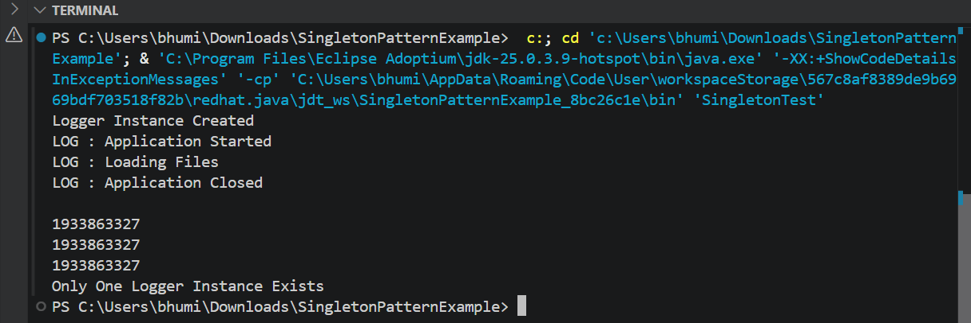

Exercise 2: Implementing the Factory Method Pattern
CODE:-

Document.java
public interface Document {

void open();
}

public abstract class DocumentFactory {

public abstract Document createDocument();
}

DocumentFactory.java:
public abstract class DocumentFactory {

public abstract Document createDocument();
}

ExcelDocument.java:
public class ExcelDocument implements Document {

@Override
public void open() {
System.out.println("Opening Excel Document");
}
}
ExcelFactory.java:
public class ExcelFactory extends DocumentFactory {

@Override
public Document createDocument() {

return new ExcelDocument();
}
}

PdfDocument.java:

public class PdfDocument implements Document {

@Override
public void open() {
System.out.println("Opening PDF Document");
}
}

PdfFactory.java:

public class PdfFactory extends DocumentFactory {

@Override
public Document createDocument() {

return new PdfDocument();
}
}

WordDocument.java:

public class WordDocument implements Document {

@Override
public void open() {
System.out.println("Opening Word Document");
}
}

WordFactory.java:

public class WordFactory extends DocumentFactory {

@Override
public Document createDocument() {

return new WordDocument();
}
}

FactoryTest.java:
public class FactoryTest {

public static void main(String[] args) {

DocumentFactory wordFactory = new WordFactory();

Document word = wordFactory.createDocument();

word.open();

System.out.println();

DocumentFactory pdfFactory = new PdfFactory();

Document pdf = pdfFactory.createDocument();

pdf.open();

System.out.println();

DocumentFactory excelFactory = new ExcelFactory();

Document excel = excelFactory.createDocument();

excel.open();
}
}

OUTPUT
